**Virologica Sinica**

**Supplementary Data**

**An optimized high-throughput SARS-CoV-2 dual reporter trans-complementation system for antiviral screening *in vitro* and *in vivo***

Yingjian Li a, Xue Tan a, Jikai Deng a, Xuemei Liu a, Qianyun Liu a, Zhen Zhang b, Xiaoya Huang a, Chao Shen a, Ke Xu a, Li Zhou b, Yu Chen a, *

a State Key Laboratory of Virology, RNA Institute, College of Life Sciences and Frontier Science Center for Immunology and Metabolism, Wuhan University, Wuhan, 430072, China

b Institute for Vaccine Research at Animal Bio-safety Level Ⅲ Laboratory, Wuhan University School of Medicine, Wuhan, 430071, China

* Corresponding author:

Email address: [chenyu@whu.edu.cn](mailto:chenyu@whu.edu.cn) (Y. Chen)

ORCID: 0000-0003-1300-4652 (Y. Chen)

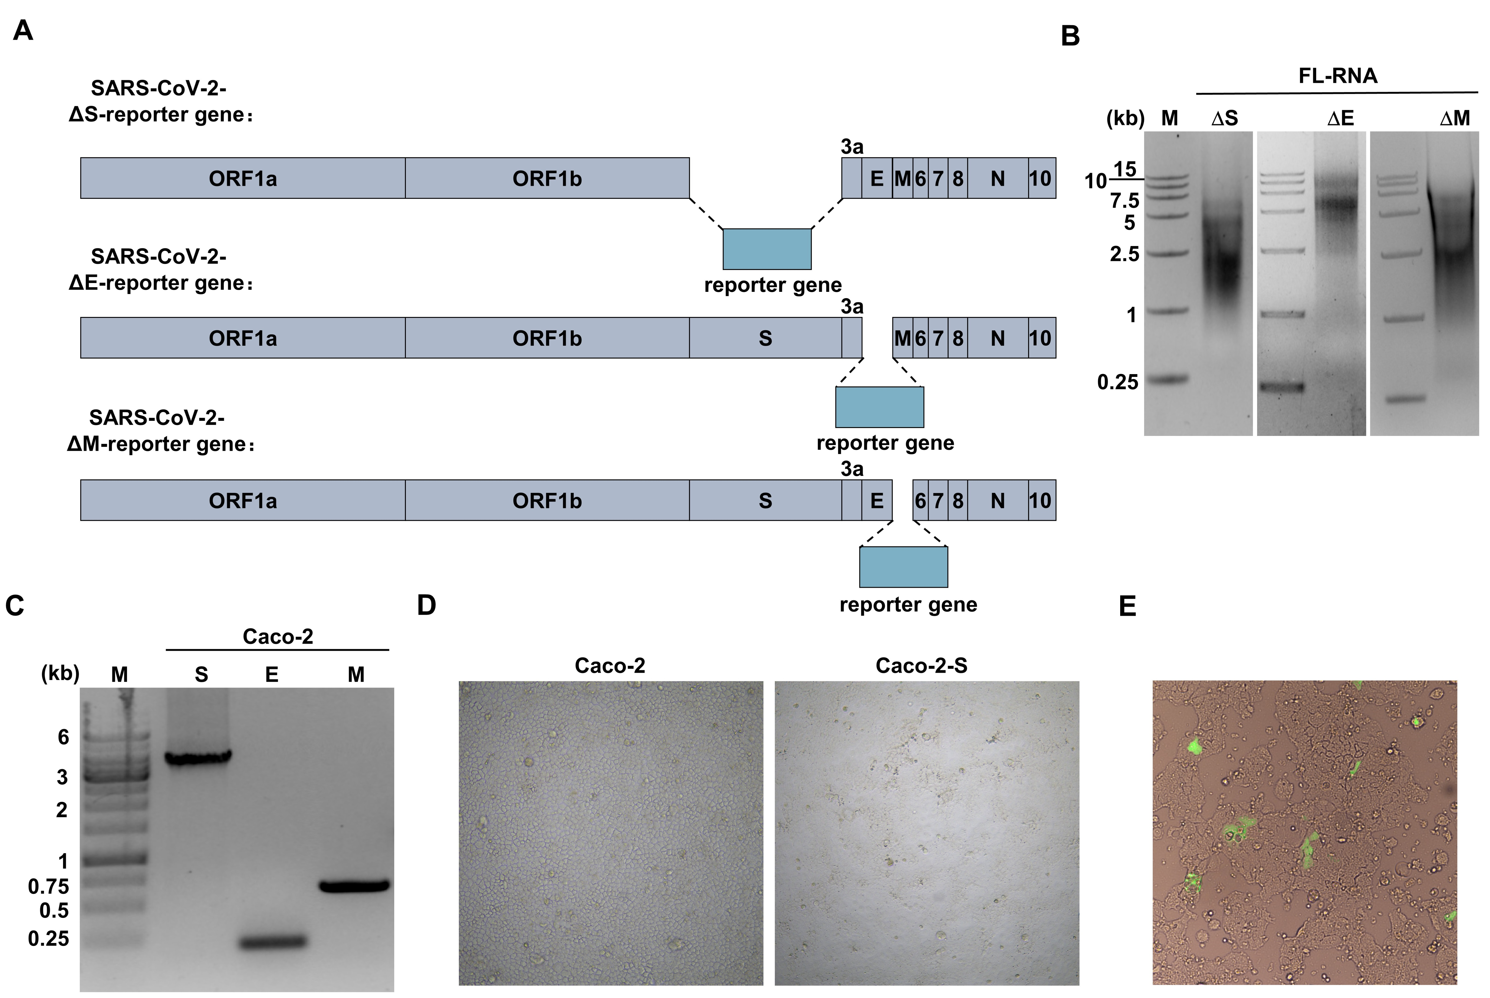

**Supplementary Figure S1.** **A** Schematic of SARS-CoV-2 ΔS, ΔE and ΔM-reporter gene RDPs. **B** The resulted *in vitro* transcript full-length mRNA was electroporated in the natural agarose gel. The DL15000 marker is indicated. **C** RT-PCR analyses were performed on transduced Caco-2 cells to detect the *S*, *E* and *M* genes, respectively. **D** Lentivirus-S transduced Caco-2 cells show cell-cell fusion. **E** The GFP signal of electroporated Caco-2-S cells.

**Supplementary Table S1.** Primers used for TAR clone.

|  |  |
| --- | --- |
| **Primer** | **Sequence** |
| SARS-CoV-2 A forward | gaattccgtttagtgaaccgTAATACGACTCACTATAGattaaaggtttataccttccc |
| SARS-CoV-2 A reverse | atcacctaactcacctactgtcttattacagtaggctaagataagtgcacaaaagttag |
| SARS-CoV-2 B forward | ctaacttttgtgcacttatcttagcctactgtaataagacagtaggtgagttaggtgat |
| SARS-CoV-2 B reverse | gaaccattaaggaatgaacccttaatagtgaaattgggcctcatagcacattggtaaa |
| SARS-CoV-2 C forward | gtttaccaatgtgctatgaggcccaatttcactattaagggttcattccttaatggttc |
| SARS-CoV-2 C reverse | atgtaagtttacatcctgattatgtacaacacctagctctctgaagtggtatccagttg |
| SARS-CoV-2 D forward | caactggataccacttcagagagctaggtgttgtacataatcaggatgtaaacttacat |
| SARS-CoV-2 D reverse | tgagtgaatatgacatagtcatattctgagccctgtgatgaatcaacagtttgagttgg |
| SARS-CoV-2 E forward | ccaactcaaactgttgattcatcacagggctcagaatatgactatgtcatattcactca |
| SARS-CoV-2 E reverse | acaactctgttgttttctctaattataagtctacctttactaagaagagataaaatcat |
| SARS-CoV-2 F forward | atgattttatctcttcttagtaaaggtagacttataattagagaaaacaacagagttgt |
| SARS-CoV-2 F reverse | ccttgcttcaaagttacagttccaattgtgaagattctcataaacaaatccataagttc |
| SARS-CoV-2 G forward | gaacttatggatttgtttatgagaatcttcacaattggaactgtaactttgaagcaagg |
| SARS-CoV-2 G reverse | gtggagatgccatgccgacccgcggccgcttttttttttttttttttttttttttgtcattctcct |
| pCC1-Trp forward | aggagaatgacaaaaaaaaaaaaaaaaaaaaaaaaaagcggccgcgggtcggcatggcatctccac |
| pCC1-Trp reverse | gggaaggtataaacctttaatctatagtgagtcgtattacggttcactaaacggaattc |